Optimizer models
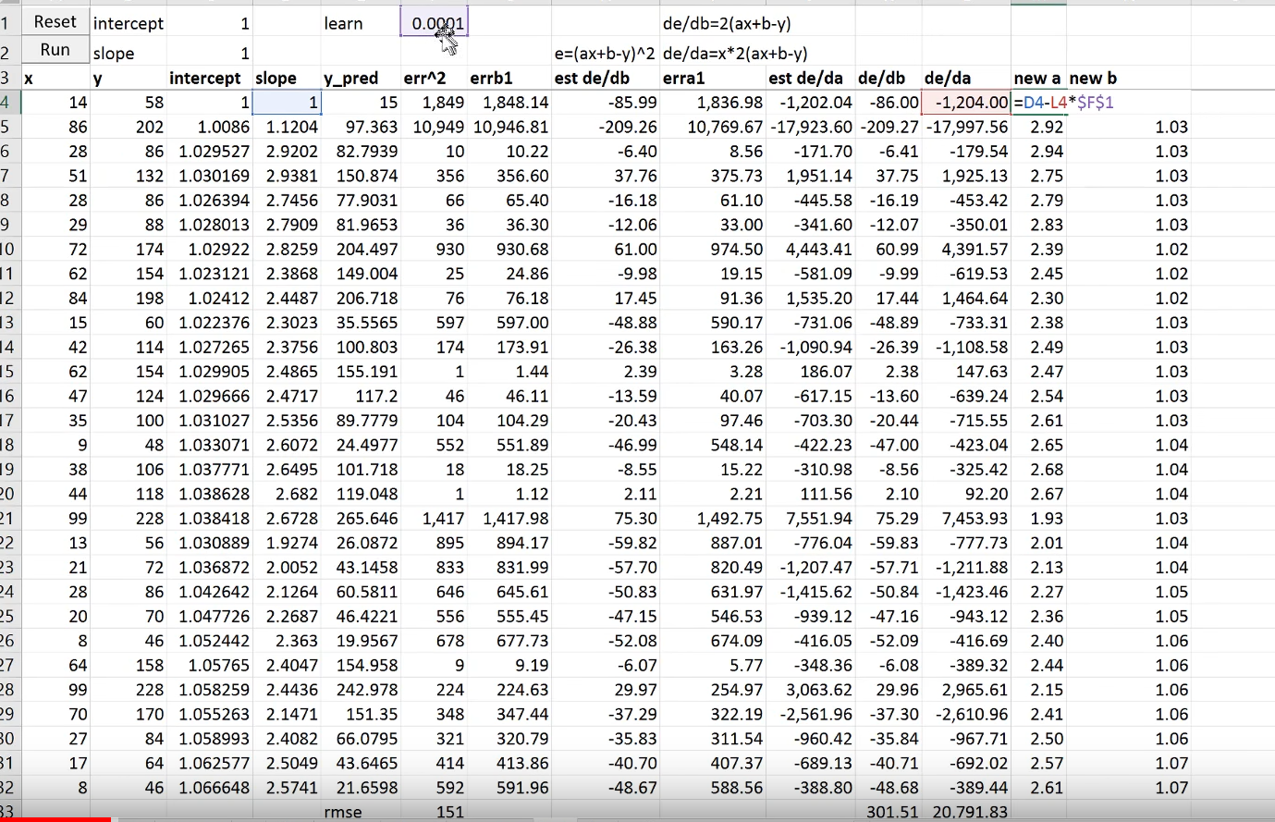
- Basic optimizer

For each batch we calculate parameters gradients and subtract them from parameters (weights / biases).
Here: est de/da – derivative (dLoss / da) by definition. We use to check whether the analytical derivative is correct.
Then we use default SGD for each batch (batch size = 1 here) in our epoch.

- Momentum
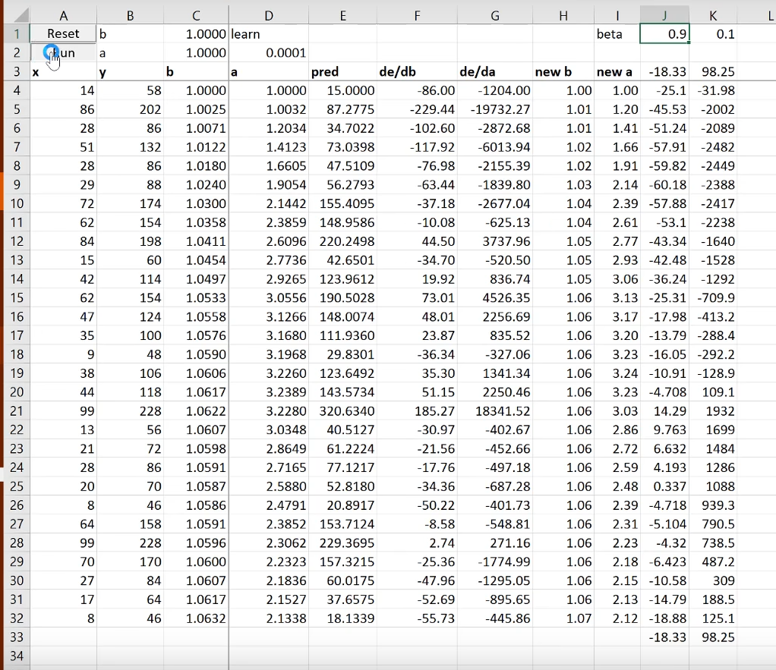
We don’t do
weights -= learning_rate * dL/dw
Instead of weight gradients we use last 2 columns for each parameter (w and b here).
Each value in these 2 columns we can count by:
x_{i} = 0.9*x_{i-1} + 0.1*dL/dw
And now we can update our parameters:
weights -= learning_rate * x_{i}
It is up to us to choose momentum parameters!

- Adagrad
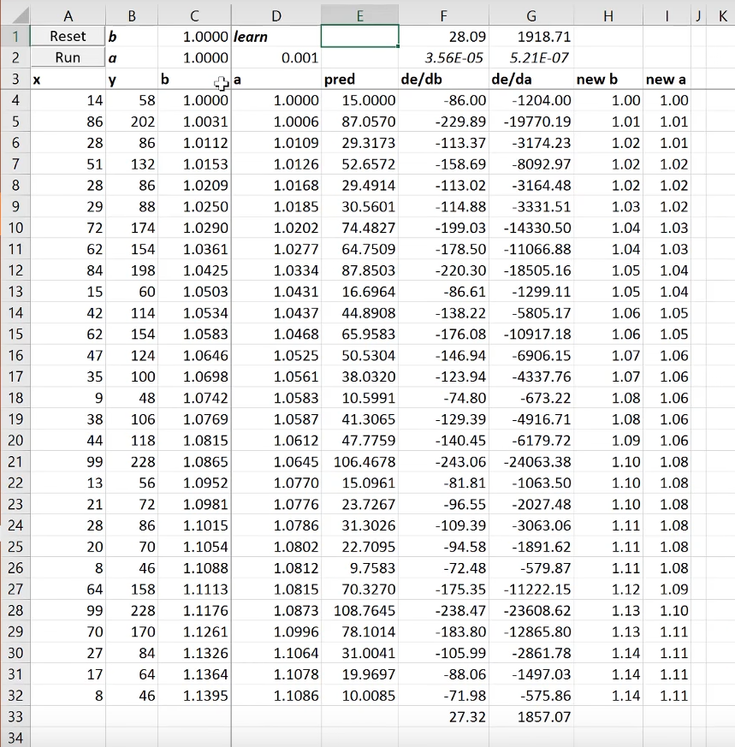
For each epoch under the derivative columns we calculate some number using:
x = √(Σ(dL/dw_{i})²) / n, where i = 1 .. n, n – number of iterations within one epoch.

The higher the magnitudes of gradients the higher this number. So after each epoch we get this number and divide our learning rates by it. (Each parameter has it’s own learning rate)

- rmsprop
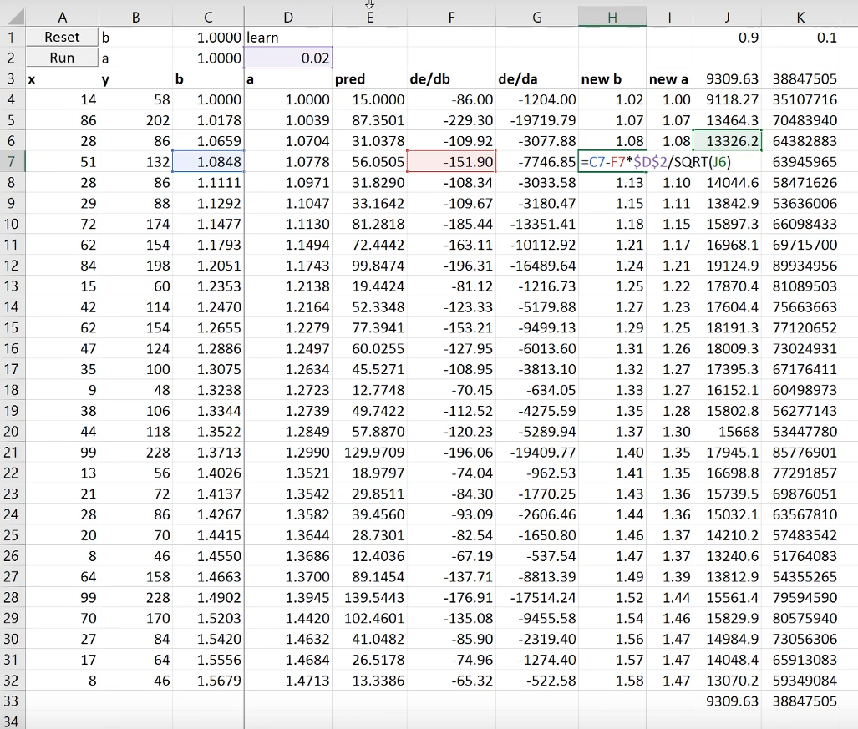
x_{i} = 0.9*x_{i-1} + 0.1*(dL/dw)²
Updating weights:
weights -= dL/dw * learning_rate/√x_{i}

- Adam
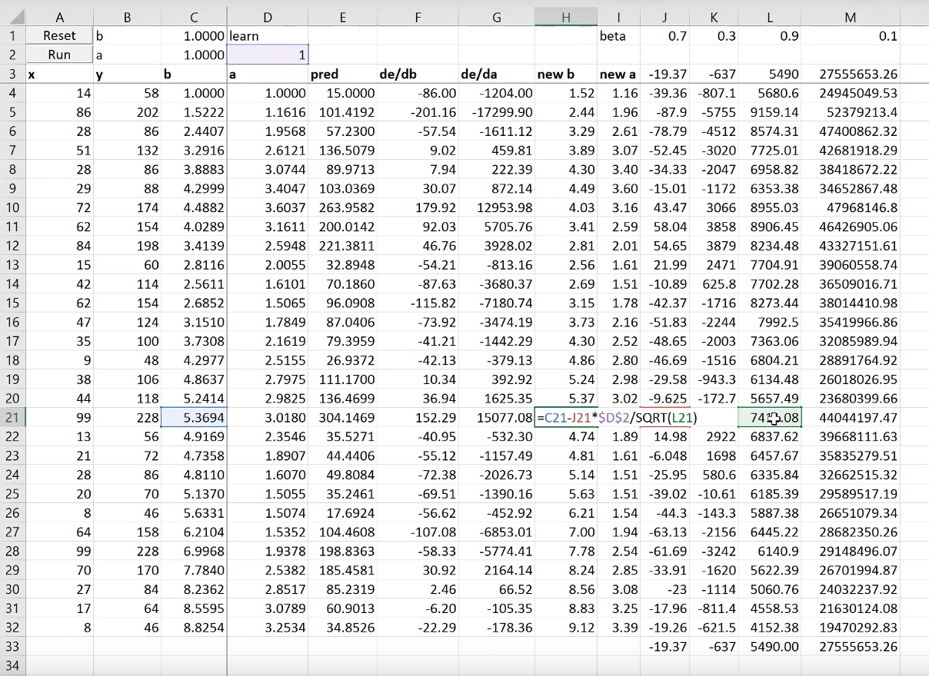
Here we combine momentum and rmsprop:
Columns J, K:
x_{i} = 0.9*x_{i-1} + 0.1*dL/dw
Columns L, M:
y_{i} = 0.9*x_{i-1} + 0.1*(dL/dw)²

weights -= x_{i} * learning_rate/√y_{i}

- Eve
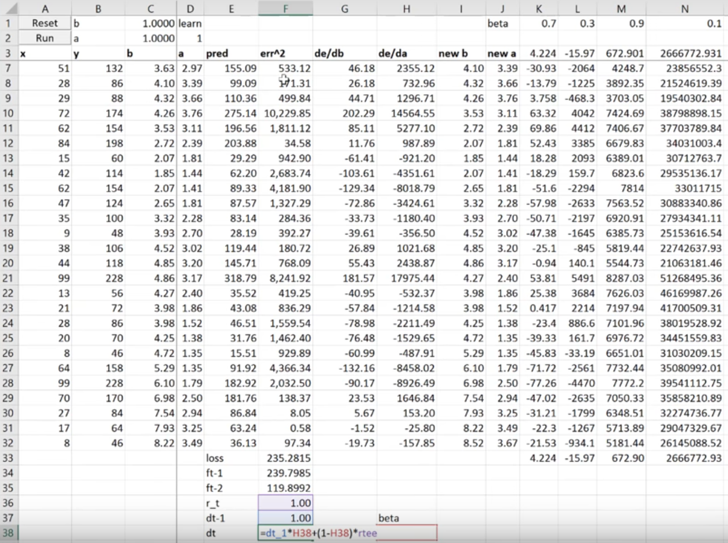
Here we keep tracked the history of the err^2 values of the previous epoch and one before it. (ft-1, ft-2)
r_t = |ft-1 – ft-2| / min(ft-1, ft-2)
dt = dt-1*0.9 + r_t*0.1

Updating learning rates:
weights -= x_{i} * learning_rate/(dt*√y_{i)}

Warning:
In the very bottom when the loss is stabilized, eve will increase learning rate.

